|  |  |
| --- | --- |
| *Pacific Gas and Electric Company* | |
| Patch 7.5.7 Installation Guide | |
|  |  |
|  |  |
| Project | ED AM/GIS |
|  |  |
| Prepared by | Ashish Narasimham |
| Date | 7/31/2013 |
| Version | 1.3 |
| Version Type | Final |

|  |  |  |  |
| --- | --- | --- | --- |
| Revision History | | | |
| Document # | Date | Author | Summary of Changes |
| 1.0 | 7/30/13 | Ashish Narasimham | Initial Document Creation |
| 1.1 | 7/31/13 | Ashish Narasimham | Added changes needed to resolve overlapping issues with DPD Job anno. Added VoltageRegulatorAnno change to cover a scenario |
| 1.2 | 7/31/13 | Ashish Narasimham | Added FuseAnno changes |
| 1.3 | 8/2/13 | Ashish Narasimham | Added SwitchAnno changes |

# Introduction

## Purpose

This document is intended to detail the implementation and configuration steps required to implement the ED AM/GIS Patch 7.5.7. This document describes the various configuration aspects required to complete any manual or automatic patch associated with this release. Each section in this document contains the steps required to patch the system in production.

## Terms Used

|  |  |
| --- | --- |
| OOTB | Out of the box. Unmodified from the commercial version. |
| TFS | Team Foundation Server |

## TFS Reference

The change requests that constitue the 7.5.5 data model release may be found in TFS using the following information.

|  |  |  |  |
| --- | --- | --- | --- |
| Ticket # | | Work Item Type | Title |
| [9157](http://edappgistfsprd1:8080/tfs/ElectricDistCollection/EDAMGIS/_workItems#_a=edit&id=9157) | | Change Request | Master Data Model 7.5.7 Patch Release |
| [9138](http://edappgistfsprd1:8080/tfs/ElectricDistCollection/EDAMGIS/_workItems#_a=edit&id=9138) | Change Request | DPD - Interrupter CCRating Annotation correction |
| [9139](http://edappgistfsprd1:8080/tfs/ElectricDistCollection/EDAMGIS/_workItems#_a=edit&id=9139) | Change Request | Streetlight Annotation correction |
| [9144](http://edappgistfsprd1:8080/tfs/ElectricDistCollection/EDAMGIS/_workItems#_a=edit&id=9144) | Change Request | Change to Dynamic Protective Device Annotation expression - add MF |
| 9214 | Change Request | Change VoltageRegulatorAnno size annotation class to not place if ratedamps is null |
| [9220](http://edappgistfsprd1:8080/tfs/ElectricDistCollection/EDAMGIS/_workItems#_a=edit&id=9220) | Change Request | Correct error in FuseAnno Job annotation class expression |
| [9258](http://edappgistfsprd1:8080/tfs/ElectricDistCollection/EDAMGIS/_workItems#_a=edit&id=9258) | Change Request | Change to Switch Annotation Job subclass to avoid OS |

## External Documents

Referenced are any external configuration documents or exports. These are documents that contain more detailed information about configuring a system or documents that can be loaded into an application to perform the configuration detailed in this document.

## Summary of Steps to Complete Patch

These are the high-level steps to complete the installation and configuration of the data model patch. Use this table as a guide for completing the installation. Links are provided that can lead either within the document for detailed explanations or to external sites such as Sharepoint.

|  |  |  |  |
| --- | --- | --- | --- |
|  | **Step Name** | **Description** | **Document Link** |
|  | Configure ArcCatalog Connection | Connect to the target database as *edgis* in ArcCatalog, creating a new named connection if necessary. | Set Up ArcCatalog Connection |
|  | DPD - Interrupter CCRating Annotation correction | Change label expression for DPD CCRating annotation class | DPD - Interrupter CCRating Annotation correction |
|  | Change to Dynamic Protective Device Default Annotation expression - add MF | Change label expression for DPD Default annotation class | Change to Dynamic Protective Device Default Annotation expression - add MF |
|  | Streetlight Annotation correction | Change label expression for Streetlight Default annotation class | Streetlight Annotation correction |
|  | VoltageRegulatorAnno Anno Correction | Change VoltageRegulatorAnno size annotation class to not place if ratedamps is null | VoltageRegulatorAnno Annotation correction |
|  | Correct error in FuseAnno Job annotation class expression | Change label expression for Job annotation class | Correct error in FuseAnno Job annotation class expression |
|  | Change to Switch Annotation Job subclass to avoid OS | Change label expression for Job annotation class |  |
|  | Update Data Model Version Table | Connect to the same server used in step 1 using *SQL Plus* as the edgis user, and run SQL to update the table. | Update Data Model Version Table |

# Set Up ArcCatalog Connection

Set up a connection in ArcCatalog to use for both automatic and manual patching.

1. Open ArcCatalog.
2. Within the Catalog Tree, expand “Database Connections” and click “Add Spatial Database Connection”.  
     
   
3. Fill in the attributes as shown below. Modify as necessary to reach the correct database.  
     
   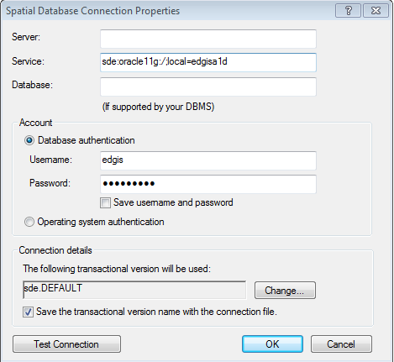

sde:oracle11g:/;local=edgisa1t

1. Click “OK”.
2. The connection will appear on the right side of the window in the Contents tab. Rename the connection appropriately.  
     
   
3. If the full path of this connection is needed, retrieve from in the following default location (path may vary based on installation and operating system):  
   C:\Users\[LAN ID]\AppData\Roaming\ESRI\Desktop10.0\ArcCatalog\[FILENAME].sde
4. Double-click on the connection within ArcCatalog to open it.

# Annotation Changes

## DPD - Interrupter Annotation Correction

### CCRating Annotation correction

1. Open ArcCatalog.
2. Within the Catalog Tree, expand “Database Connections” and open the active connection for this process (as defined in section 2).
3. Within the ElectricDataset, right-click on the “DynamicProtectiveDeviceAnno” annotation feature class and click “Properties”.
4. Click on the “Annotation Classes” tab.
5. Select the “CCRating” annotation class.
6. Click “Expression” next to the Label Field dropdown.

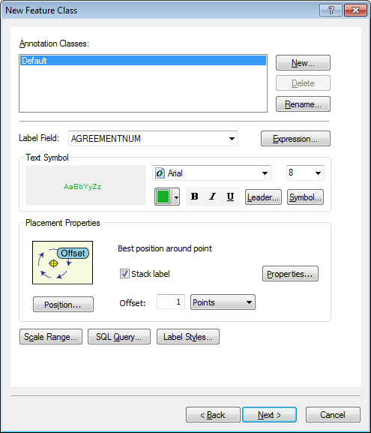

1. Match the label text with the text below, click verify, and then click “OK”.

CCRating annotation expression

Function FindLabel ( [SubtypeCD], [CCRating], [SwitchModeIdc])

if [SwitchModeIdc]= "Yes" then

FindLabel = [CCRating] & "A-SM"

else

FindLabel = [CCRating] & "A"

End if

End Function

1. Click “Apply”.
2. Select the  button at the bottom of the screen and enter the following text into the input box:

SubtypeCD = 2

1. It should look like the following image after the text has been inserted:

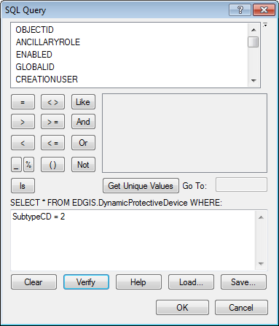

1. Click “OK”.

### DPD Job Annotation Correction

1. Select the “Job” annotation class.
2. Select “Symbol” and then “Edit Symbol” in the “Text Symbol” Area of the window.
3. Set the Y-Offset to “-40”  
   
4. Click “Expression” next to the Label Field dropdown.



1. Match the label text with the text below, click verify, and then click “OK”.

Function FindLabel ( [InstallJobPrefix], [InstallJobNumber], [InstallJobYear], [SUBTYPECD],  [SWITCHMODEIDC]  )

myString = ""

if isNull( [INSTALLJOBNUMBER]) or [INSTALLJOBNUMBER]  = "0" or  _

   instr(ucase( [INSTALLJOBNUMBER]), "CEDSA") then

else

  if left(ucase( [INSTALLJOBPREFIX]), 3 ) <> "UNK" and _

      ucase( [INSTALLJOBPREFIX]) <> "FIF" and _

      len( [INSTALLJOBPREFIX]) > 0 then

    myString = [INSTALLJOBPREFIX]

  end if

  if len( [INSTALLJOBYEAR]) > 0 then

    if len( [INSTALLJOBYEAR]) = 4 then

      myString = myString + [INSTALLJOBNUMBER]  + " '"+ right( [INSTALLJOBYEAR],2)

    elseif len( [INSTALLJOBYEAR]) = 2 then

      myString = myString + [INSTALLJOBNUMBER]  + " '"+ [INSTALLJOBYEAR]

    end if

  else

    myString = myString + [INSTALLJOBNUMBER]

  end if

end if

If [SubtypeCD]= "Recloser" or [SubtypeCD]= "Sectionalizer" or [SubtypeCD]= "Interrupter" then

  If [SubtypeCD]<> "Interrupter" then

     FindLabel = myString +  vbCrLf +  chr(129) + vbCrLf + chr(129)

  else

    FindLabel = myString + vbCrLf + chr(129)

  end if

else

  FindLabel = myString + vbCrLf + chr(129) + vbCrLf + chr(129) + vbCrLf + chr(129)

end if

End Function

1. Click “Apply” and “OK”. Keep the DPDAnno window open as we will be using this for the next step.

## Change to Dynamic Protective Device Default Annotation expression - add MF

1. Select the “Default” annotation class. You should be in the DPDAnno window already from the previous step.
2. Click “Expression” next to the Label Field dropdown.



1. Match the label text with the text below, click verify, and then click “OK”.

Function FindLabel ( [SubtypeCD] ,[OperatingNumber], [MULTIFUNCTIONALIDC] )  
If [SubtypeCD] = "Recloser" and [MULTIFUNCTIONALIDC] = "Yes" then  
  FindLabel = [OperatingNumber] & "-MF"  
else  
  FindLabel = [OperatingNumber]  
end if  
End Function

1. Click “Apply”.
2. Click “OK” and “OK” on the main window.

## Streetlight Annotation correction

1. Open ArcCatalog.
2. Within the Catalog Tree, expand “Database Connections” and open the active connection for this process (as defined in section 2).
3. Within the ElectricDataset, right-click on the “Streetlight” annotation feature class and click “Properties”.
4. Click on the “Annotation Classes” tab.
5. Select the “Default” annotation class.
6. Click “Expression” next to the Label Field dropdown.



1. Match the label text with the text below, click verify, and then click “OK”.

Function FindLabel ( [Ownership], [StreetLightNumber]   )

If [Ownership]<> "Company" then  
  FindLabel =  [StreetLightNumber]  & vbCrLf & "C"  
else  
  FindLabel =  [StreetLightNumber]  
End if

End Function

1. Click “Apply”.
2. Click “OK” on the main window.

## VoltageRegulatorAnno Annotation correction

1. Open ArcCatalog.
2. Within the Catalog Tree, expand “Database Connections” and open the active connection for this process (as defined in section 2).
3. Within the ElectricDataset, right-click on the “VoltageRegulatorAnno” annotation feature class and click “Properties”.
4. Click on the “Annotation Classes” tab.
5. Select the “Size” annotation class.
6. Select the  button at the bottom of the screen and enter the following text into the input box:

RATEDAMPS is not null

1. It should look like the following image after the text has been inserted:

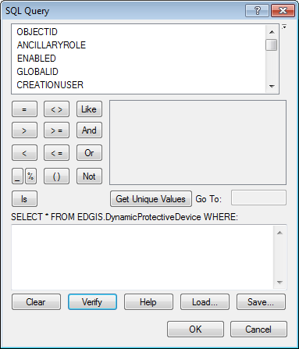

RATEDAMPS is not null

1. Click “OK” and “OK” again on the main window.

## Correct error in FuseAnno Job annotation class expression

1. Open ArcCatalog.
2. Within the Catalog Tree, expand “Database Connections” and open the active connection for this process (as defined in section 2).
3. Within the ElectricDataset, right-click on the “FuseAnno” annotation feature class and click “Properties”.
4. Click on the “Annotation Classes” tab.
5. Select the “Job” annotation class.
6. Click “Expression” next to the Label Field dropdown.



1. Match the label text with the text below, click verify, and then click “OK”.

Function FindLabel ( [INSTALLJOBPREFIX], [INSTALLJOBNUMBER], [INSTALLJOBYEAR], [LINKTYPE], [LINKRATING] )  
myString = ""

if isNull( [INSTALLJOBNUMBER] ) or [INSTALLJOBNUMBER]  = "0" or  _  
   instr(ucase( [INSTALLJOBNUMBER] ), "CEDSA") then  
else  
  if left(ucase( [INSTALLJOBPREFIX]), 3 ) <> "UNK" and _  
      ucase( [INSTALLJOBPREFIX] ) <> "FIF" and _  
      len( [INSTALLJOBPREFIX] ) > 0 then  
    myString = [INSTALLJOBPREFIX]   
  end if  
  if len( [INSTALLJOBYEAR] ) > 0 then  
    if len( [INSTALLJOBYEAR] ) = 4 then  
      FindLabel = myString + [INSTALLJOBNUMBER]  + " '"+ right( [INSTALLJOBYEAR] ,2) + vbCrLf + chr(129)  
    elseif len( [INSTALLJOBYEAR] ) = 2 then  
      FindLabel = myString + [INSTALLJOBNUMBER]  + " '"+ [INSTALLJOBYEAR] + vbCrLf + chr(129)  
    end if  
  else  
    FindLabel = myString + [INSTALLJOBNUMBER] + vbCrLf + chr(129)  
  end if  
   if (uCase([LINKTYPE]) = "UNSPECIFIED" or uCase( [LINKTYPE] ) = "NOT ON LIST") and [LINKRATING] = "9999 A" then  
     FindLabel = FindLabel + vbCrLf + chr(129)  
   end if  
end if

End Function

1. Click “Apply”.
2. Click “OK” on the main window.

## Change to Switch Annotation Job subclass to avoid OS

1. Open ArcCatalog.
2. Within the Catalog Tree, expand “Database Connections” and open the active connection for this process (as defined in section 2).
3. Within the ElectricDataset, right-click on the “SwitchAnno” annotation feature class and click “Properties”.
4. Click on the “Annotation Classes” tab.
5. Select the “Job” annotation class.
6. Click “Expression” next to the Label Field dropdown.



1. Match the label text with the text below, click verify, and then click “OK”.

Function FindLabel ( [INSTALLJOBPREFIX] , [INSTALLJOBNUMBER] , [INSTALLJOBYEAR], [SUBTYPECD], [CCRATING] )  
pad = vbCrLf + chr(129)  
If [SubtypeCD] = 2 then  
  if [CCRating] = "600" or [CCRating] = "800" then  
    pad = ""  
  end if  
End if  
myString = ""  
if isNull( [INSTALLJOBNUMBER] ) or [INSTALLJOBNUMBER]  = "0" or  _  
   instr(ucase( [INSTALLJOBNUMBER] ), "CEDSA") then  
else  
  if left(ucase( [INSTALLJOBPREFIX]), 3 ) <> "UNK" and _  
      ucase( [INSTALLJOBPREFIX] ) <> "FIF" and _  
      len( [INSTALLJOBPREFIX] ) > 0 then  
    myString = [INSTALLJOBPREFIX]   
  end if  
  if len( [INSTALLJOBYEAR] ) > 0 then  
    if len( [INSTALLJOBYEAR] ) = 4 then  
      FindLabel = myString + [INSTALLJOBNUMBER]  + " '"+ right( [INSTALLJOBYEAR] ,2) + vbCrLf + chr(129) + pad  
    elseif len( [INSTALLJOBYEAR] ) = 2 then  
      FindLabel = myString + [INSTALLJOBNUMBER]  + " '"+ [INSTALLJOBYEAR] + vbCrLf + chr(129) + pad  
    end if  
  else  
    FindLabel = myString + [INSTALLJOBNUMBER] + vbCrLf + chr(129) + pad  
  end if  
end if  
End Function

1. Click “Apply”.
2. Click “OK” on the main window.

# Update Data Model Version Table

**Database Configuration:**

1. Open SQL Plus.
2. Log in using the same server and user as was used in section 2.  
     
   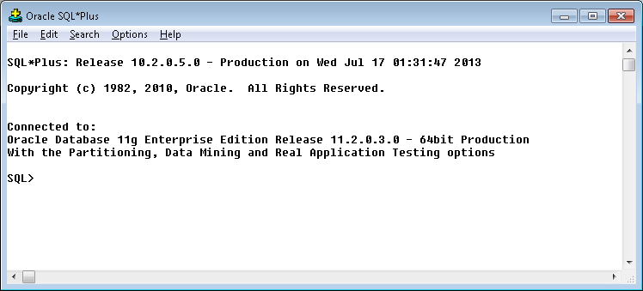
3. Run the SQL below:

update pgedatamodelversion set currentidc='N' where currentidc='Y';

insert into pgedatamodelversion (OBJECTID, CURRENTIDC, DATEAPPLIED, APPLIEDBYPERSONNAME, MODELVERSION) values (30,'Y',sysdate,'Ashish Narasimham','7.5.7 GOLD CR9157');

# Known Issues

<Please List any other issues encountered here while following the document>